TJA, 9. razred
ponedeljek, 18. 5. 2020 (19. šolska ura dela na daljavo)
Pozdravljeni. Danes boste najprej poslušali novo epizodo zgodbe Sweet Sue and Smart Alec, potem pa še vadili uporabo trpnika v sedanjem času (Passive voice: present).
Čim prej se lotite dela, da vam bo ostalo veliko časa za druge stvari.

Ne pozabite nam svojega dela poslati do srede,
20. maja 2020.

Sledite spodnjim navodilom. Vaje rešujte v zvezek (učbenik, stran 60) ali kar v ta dokument. Če potrebujete pomoč pri tem, sporočite.

Unit 5 (Student's book page 60)
Caring for the environment
Reading comprehension

1a Look at the title and the pictures. What do you think the text is about?
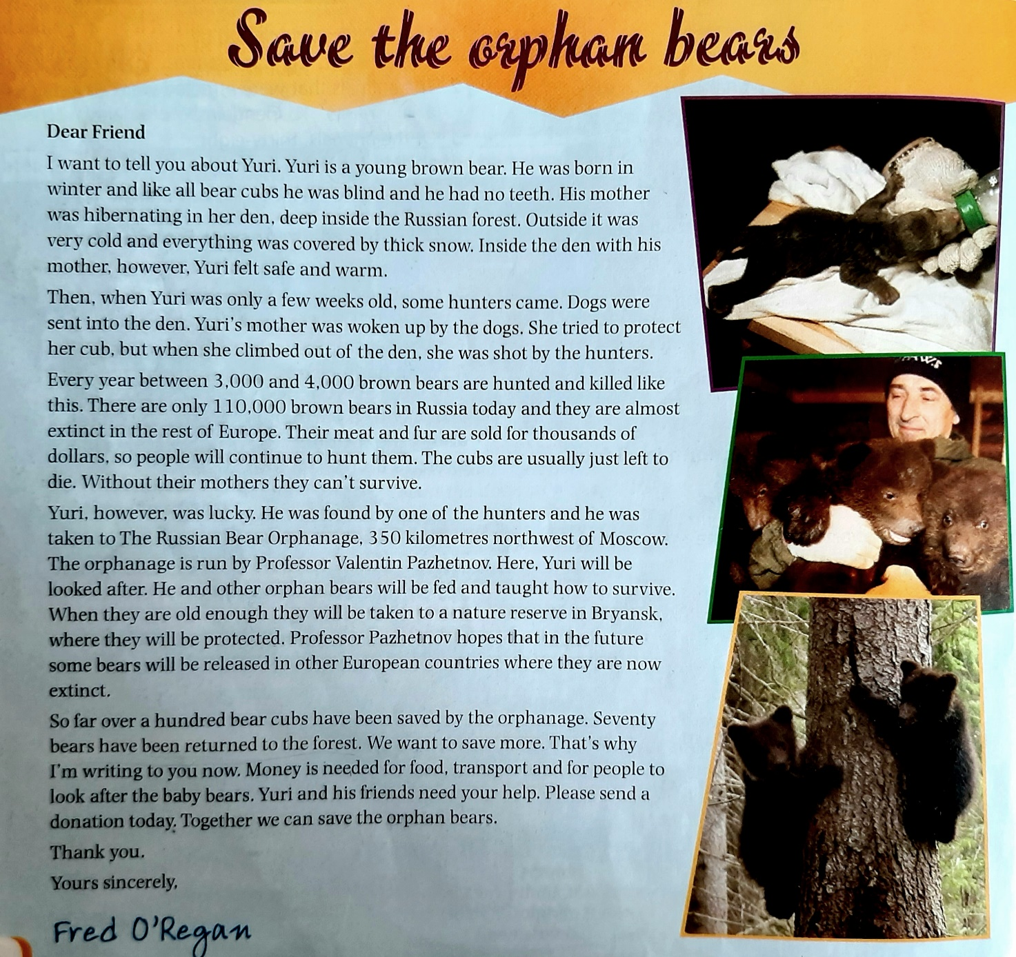
1b Read and listen to the text. What does the writer want?
1c Who or what are these?
- Yuri Kliknite ali tapnite tukaj, če želite vnesti besedilo.
- Valentin Pazhetnov Kliknite ali tapnite tukaj, če želite vnesti besedilo.
- Fred O'Regan Kliknite ali tapnite tukaj, če želite vnesti besedilo.
- The Russian Bear Orphanage Kliknite ali tapnite tukaj, če želite vnesti besedilo.
- Bryansk Kliknite ali tapnite tukaj, če želite vnesti besedilo.

2 Are the statements true or false or doesn't it say?
- Yuri's mother died. Izberite element.
- The hunters' dogs killed her. Izberite element.
- Hunters usually shoot the cubs, too. Izberite element.
- There are only 200 bears in the rest of Europe. Izberite element.
- Yuri was found in a forest near Moscow. Izberite element.
- Professor Pazhetnov has saved over 100 bears. Izberite element.
- Some of the bears have been released in Poland. Izberite element.
- All the orphan bears have survived. Izberite element.

Spodnjo nalogo pa naredite samo tisti, ki ste pri učiteljici Saši ali učiteljici Franji. Seveda pa jo lahko naredite tudi vsi ostali, če želite.
3 Discuss the questions.
- How do you feel when you read about the orphan bears? Kliknite ali tapnite tukaj, če želite vnesti besedilo.
- What effect do the pictures have? Kliknite ali tapnite tukaj, če želite vnesti besedilo.
- Why is the leaflet in the form of a letter? Kliknite ali tapnite tukaj, če želite vnesti besedilo.
- Who is the letter addressed to? Why? Kliknite ali tapnite tukaj, če želite vnesti besedilo.
- Would you send money to help? Why? Why not? Kliknite ali tapnite tukaj, če želite vnesti besedilo.
- What other animals are in danger? Why? Kliknite ali tapnite tukaj, če želite vnesti besedilo.
- How are animals treated in your country? Kliknite ali tapnite tukaj, če želite vnesti besedilo.

REŠITVE
1a The text is aobut looking after baby bears whose mothers have been killed.
1b He wants money for the bear orphanage.
1c
- Yuri: a young brown bear
- Valentin Pazhetnov: the professor who runs the bear orphanage
- Fred O'Regan: the writer of the letter
- The Russian Bear Orphanage: the place where they care for bears who have lost their mothers
- Bryansk: the location of the nature reserve where the bears are sent to after the orphanage
2
- T
- F
- F
- DS
- DS
- T
- F
- DS
3 Your own answers.

